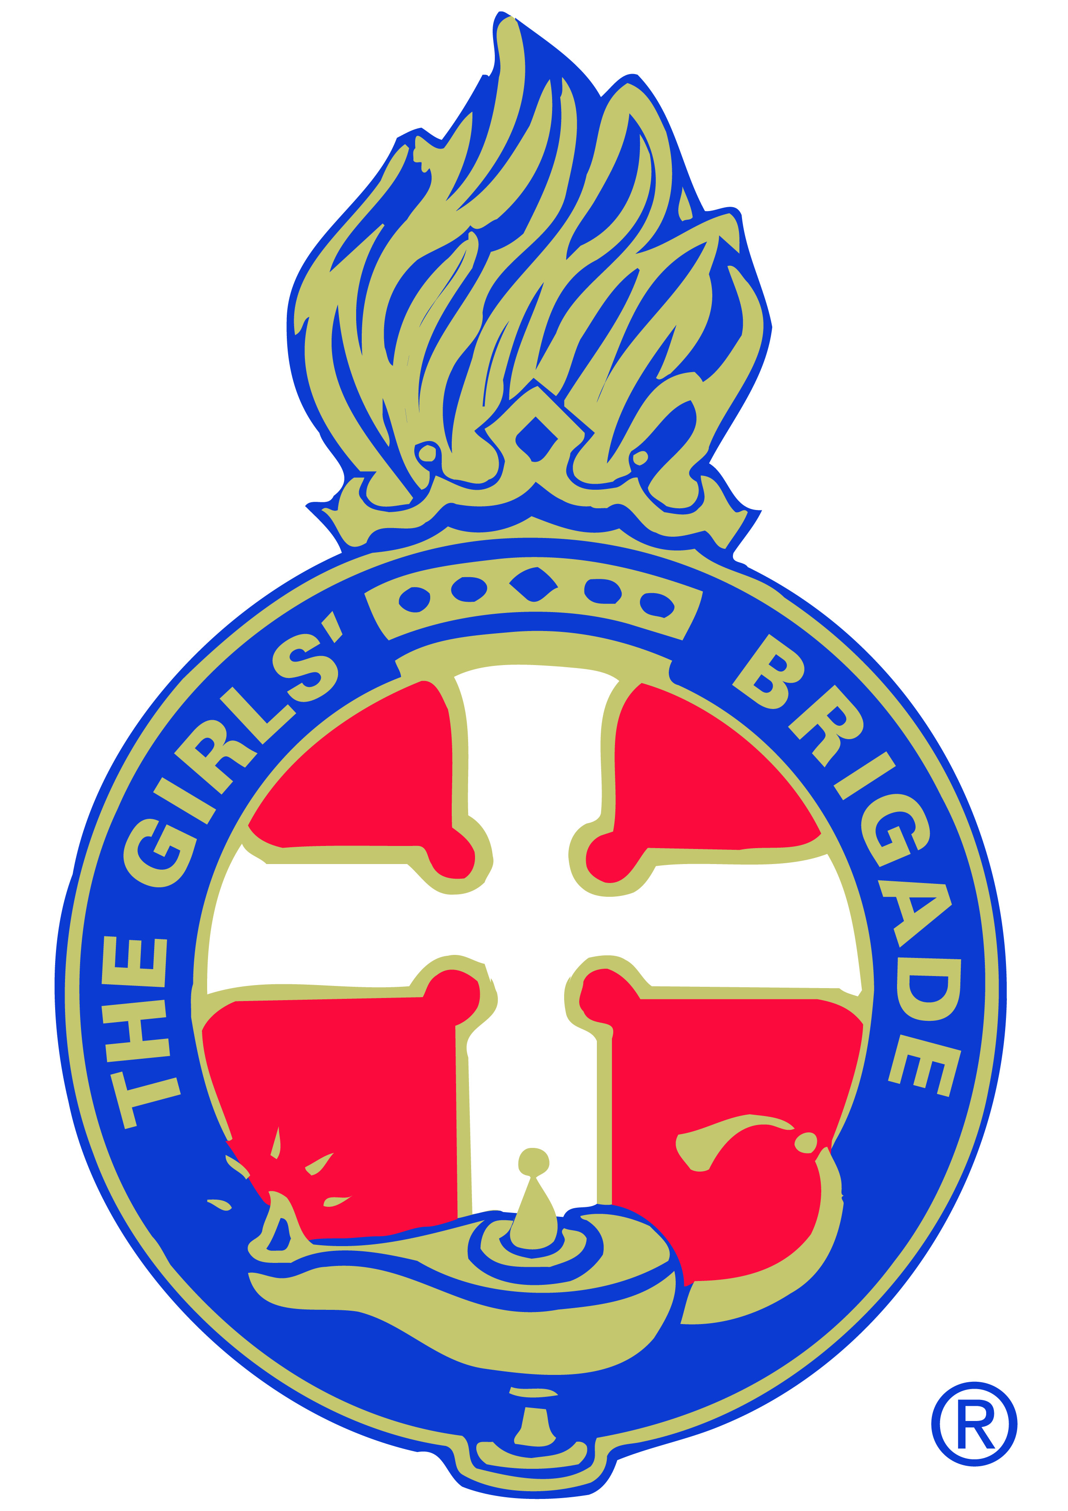
THE GIRLS’ BRIGADE NEW ZEALAND INCORPORATED
(including Girls’ Brigade and iconz4girlz)
iconz4girlz LEADER’S REGISTRATION FORM
Leaders’ Registrations, Police Vetting and Code of Conduct are required to be renewed every three years in accordance with the GBNZ Memorandum of Understanding (2019)
Title:
First Name: Last Name:
Street Address: Suburb:
Town/City: Postcode:
Date of Birth: Email:
Home Phone: Cell Phone:
Ethnicity: Occupation:

Declaration
- I wish to become the Senior Leader / a leader (circle one) in the iconz4girlz Unit at
__________________________________________________ Church.
- I have signed and will comply with the GBNZ Code of Conduct.
- I have completed a Police Vetting Consent Form
- I give/do not give consent for photographic images (including video) taken of me involved in iconz4girlz activities to be used for administration, promotional and publicity purposes.
- I will undertake introductory training and am willing to accept further training opportunities for leadership development.
In seeking registration:
- I acknowledge my dependence upon God - Father, Son and Holy Spirit.
- I promise to seek His help in deepening my own spiritual life.
- I commit myself to the service of the girls and leaders in this Unit.

Signature: Date:

Continued overleaf……….

CHURCH ENDORSEMENT
CHURCH ENDORSEMENT

It is hereby advised that the above leader has been trained in the Health and Safety and Child Protection Policies of this church and has received Police Vetting clearance. If clearance is still pending GBNZ will be advised when received.

Training in Health and Safety Policy at this church completed | Instructor:  Date:
Training in Child Protection Policy at this church completed | Instructor:  Date:
Delete one:  Police Vetting Clearance pending (or)  Police Vetting Clearance received | Date:

Endorsed on behalf of the church for appointment as a leader in our iconz4girlz Unit by:
Name: Position (Pastor/Minister/Elder):
Signature: Date:

TO BE COMPLETED BEFORE IFG TRAINING WORKSHOP

It is hereby advised that the above leader has been trained in the Health and Safety and Child Protection Policies of this church and has also received Police Vetting clearance.

Training in church Health and safety Policy completed | Date:
Training in church Child Protection Policy completed | Date:
Police Vetting Clearance received | Date:

Endorsed on behalf of the church for appointment as a leader in our iconz4girlz Unit by:
Name: Position (Pastor/Minister/Elder):
Signature: Date:

Introduction to iconz4girlz Training Completed: (delete one)
- Equip and Launch Workshop for leaders in new Units

- Toolbox4Leaders Module for leaders in existing Units
Training Provided by: Position:
Signature: Date:

GBNZ Support Centre Use:
Checked and approved by: |  | Date:
Entered into database by: |  | Date:

The above information will be held on record by Girls’ Brigade New Zealand Incorporated for the purpose of administration and promotion. This complies with the Privacy Act 1993.

